

MATHEMATICS
METHODS

Test 2 – Equations, Polynomials, Functions and Graphs

Chapters 1 and 4
Semester 1 2015

Section One - Calculator Free

Time allowed for this section
Working time for this section: 25 minutes
Marks available: 24 marks

Material required/recommended for this section

To be provided by the supervisor
This Question/Answer booklet
Formula sheet

To be provided by the candidate
Standard items: pens, pencils, pencil sharpener, eraser, correction fluid, ruler, highlighters

Special items: drawing instruments, templates, notes and up to three calculators satisfying the conditions set by the Curriculum Council for this course.

Important note to candidates
No other items may be used in this section of the examination. It is your responsibility to ensure that you do not have any unauthorised notes or other items of a non-personal nature in the examination room. If you have any unauthorised material with you, hand it to the supervisor before reading any further.

Multiple choice questions – select the best response
- (1 mark)
Find the equation of the function that is 5 units to the left of y = x2 and 1 unit down.
A y = (x + 5)2 − 1 B y = (x + 5)2 + 1
C y = (x − 5)2 + 1 D y = 5x2 − 1
E y = (x − 5)2 – 1
- (1 mark)
Find the gradient of the line that is perpendicular to the straight line with equation
2x + 6y − 1 = 0
A −3 B
C D
E 3

- (1 mark)
Make a the subject of the formula v2 = n2(a2 – x2).
A B
C D
E

- (1 mark)
One or more errors have been made in the solution to this linear equation. State where the error(s) occurred.
A Line 1 only B Line 2 only
C Line 3 only D Line 1 and Line 2
E Line 1, Line 2 and Line 3
- (2 marks)
Which graph is not a function? Indicate on your choice your reason.
A 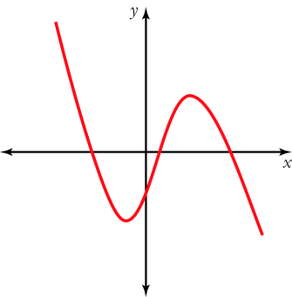 B 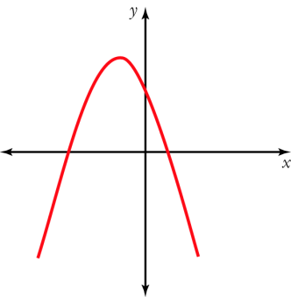 C 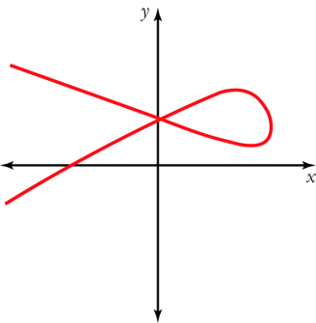

D 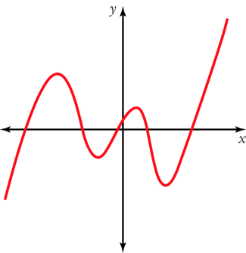 E 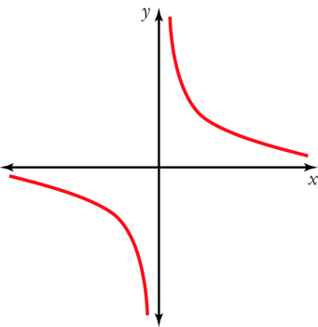

Short Answer Questions
- (2 marks)
Solve 3 + 2(m – 4) = 4m – (3m – 2)

- (4 marks)
Solve the following equations:
- (3x – 2)(x + 9) = 0

- x2 – 7x + 4 = 0 (using the quadratic formula)

- (4 marks)
Mike had a pen with chickens and rabbits in it. Between them, the animals had 42 heads and 142 feet. Write equations and solve them to find out how many chickens and how many rabbits there were in the pen.

- 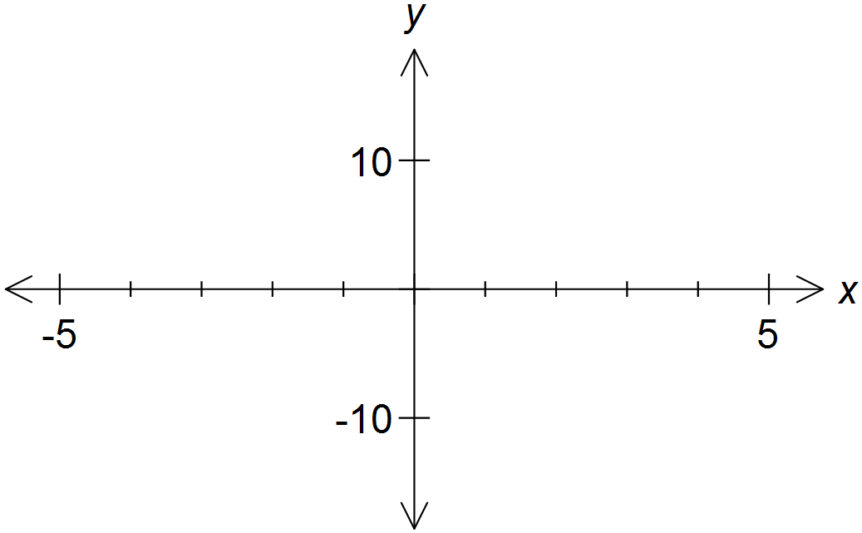(8 marks)
Sketch the following functions:

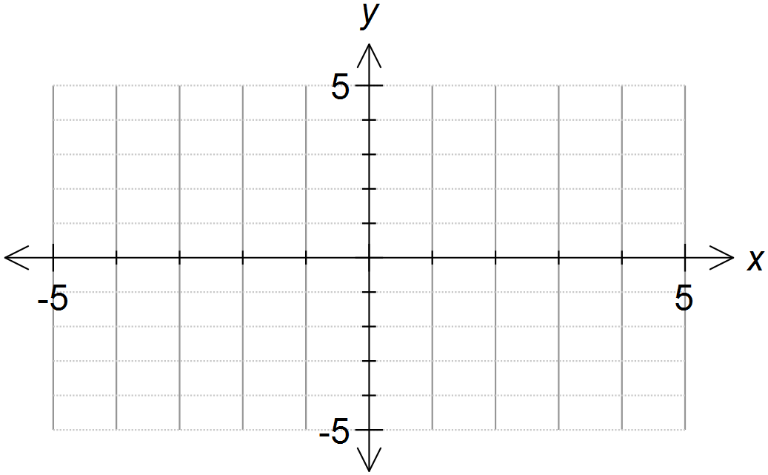

End of Section One

